**

Sailing Instructions

Barefoot Sailing Club and Lake Lanier Sailing Club

2023 Joan Holcomb Memorial Woman Skippers Race

# **1.Rules**

* 1. Rules shall be governed by *“the Rules”* as defined in the Racing Rules of Sailing (RRS).

1.2 It is a requirement that a woman helm the boat. A woman is also to be making the strategic and tactical decisions for the race. The remainder of the crew can be made up of women and men.

**2. Communications with Competitors**

2.1 Notices to competitors will be posted on the official notice board at **Barefootsailingclub.org**

2.2 On the water, the race committee intends to monitor and communicate with competitors on VHF radio. **Keelboats will be on channel 69** and **Centerboard/Portsmouth will be on channel 71**.. The race committee may designate an alternate channel as needed.

2.3 Voice and data transmission from a boat is restricted from the first warning signal until the end  
 of the last race of the day. A boat shall not make voice or data transmissions and shall not  
 receive voice or data communication that is not available to all boats, except in an emergency or as required by a rule.

**3. Radio Communication**

3.1 Courtesy broadcasts of the race courses and the starting sequences may be made on VHF, channel to be posted at Skippers Meeting.

3.2 The failure of boats to have a working VHF radio, the misinterpretation of the courtesy broadcast, or failure of the Race Committee to provide the broadcast shall not be grounds for redress.

**4. Changes to Sailing Instructions**

4.1 Any change to the sailing instructions, including any change to the schedule of event, shall be announced at the Skippers’ Meeting.

4.2 The latest version of the sailing instructions shall be available on Barefootsailingclub.org website.

4.3 Changes to sailing instructions that would affect the racing for that race day shall be posted no later than one hour prior to the schedule start time of the first race of that day on the official bulletin board (whiteboard) at LLSC clubhouse.

4.4 Oral changes to sailing instructions may not be made on the water. Changes that have been appropriately made in writing and properly posted may also be announced verbally on the water by the Race Committee.

**5. Signals Made Ashore**

5.1 Signals made ashore will be displayed from the flagpole located on the main lawn of the LLSC Pavilion.

5.2 When flag AP is displayed ashore, ‘1 minute’ is replaced with ‘not less than 45 minutes’ in Race Signals AP.

**6. Schedule of Races**

6.1 The racing schedule is posted on the website BarefootSailingClub.org.

6.2 The scheduled time of the warning signal for the first race for both courses (Keelboat and Centerboard) will be 10:55am.

6.3 Subsequent races will be held. No race will start after 4pm.

**7. Class Flags**

7.1 Class flags for all fleets will be described on a board displayed from the stern of the race committee barge prior to the warning signal of the first race of the day.

7.2 Centerboard Portsmouth course will use one design or solid color flag to designate fleet start

7.3 Keelboat fleets will use number code flags.

**8. Racing Area**

8.1 All Races will start on Lake Sidney Lanier, Georgia in Chattahoochee Bay.

a) Centerboard Portsmouth fleet will meet in the vicinity of “T” mark.

b) Keelboat fleet start will be announced at the skipper’s meeting and may be changed on the water.

8.2 Final decision of start location will be announced at the Skipper’s Meeting.

8.3 Changes may also be made by a posted notice on a Race Committee boat.

8.4 A map of the racing area is provided as Appendix B

**9. The Courses**

9.1 **Centerboard/ Portsmouth course**:

a) It is anticipated that Windward/Leeward courses will be set.

b) The race course for centerboard/Portsmouth boats will be indicated by displaying one of the courses noted in Appendix A on the Race Committee’s boat course board(s).

c) A Windward Mark (WM) or a Distance Weather Mark (DWM), and a Leeward Mark (LM) may be used.

d) The compass course to the DWM will be posted on the course board when DWM is specified.

9.2 **Keelboat course:**

a) The race course will be indicated by displaying the course on the Race committee’s boat course board(s).

b) The numbers and letters posted on the board refer to permanent marks that must be left either to port or to starboard as indicated on the posted course

**10. Marks**

**10.1 Centerboard/ Portsmouth course**

a) The temporary marks used for course marks on buoy courses are inflatable tetrahedrons (pyramids).

b) The starting and finishing marks will be a small tetrahedron or a round ball.

**10.2 Keelboat course**:

a) Mark(s) may be a combination of Corps of Engineers (CoE) permanent marks, LARC permanent marks (A, B, C, D, E, F, H, T, and X), the LLSC Flagpole and temporary marks will be a tetrahedron.

b) A temporary mark may be placed in the vicinity of a CoE or LARC permanent mark if the mark is missing or the water is too shallow at the mark. For example, "13T-P" would mean to round a temporary mark near CoE mark 13, leaving it to port.

c) The starting mark will either be a LARC permanent mark, small tetrahedron or a round ball.

d) Location of the islands and permanent marks are indicated on the map shown in Appendix B.

**11. The Start**

11.1 The order of starts shall be determined by the Race Committee (RC), and will be displayed on the Race Committee’s boat course board(s).

11.2 The Starting line will be between a staff displaying an orange flag on the Race Committee boat and a nearby mark.

11.3 If the Race Committee intends to start another race on the same day, it will display the **2nd Substitute** with no horn. Boats that finish should remain close to the Race Committee boat but off the race course.

11.4 The Race Committee reserves the right to begin the sequence for any fleet individually without having to wait for other fleets to finish. The Race Committee will begin the starting sequence as soon as practical [finishing fleet(s) take precedence]

**11.4 Centerboard/Portsmouth**

Races will be started with the warning signal three (3) minutes before the start. The starting sequence is shown below.

|  |  |  |  |
| --- | --- | --- | --- |
| **3 min** | **Warning** | **Class Flag raised** | **1 blast of the horn.** |
| **2 min** | **Preparatory** | **P flag raised \*** | **1 blast of horn** |
| **1 min** | **Preparatory** | **P flag lowered \*** | **1 long blast of horn** |
| **0 min** | **Start** | **Class flag lowered for the start** | **1 blast of horn** |

**11.5 Keelboats**

Races will be started by using rule 26 with the warning signal five (5) minutes before the start. The starting sequence is shown below.

|  |  |  |  |
| --- | --- | --- | --- |
| **5 min** | **Warning** | **Class Flag raised** | **1 blast of the horn.** |
| **4 min** | **Preparatory** | **P flag raised \*** | **1 blast of horn** |
| **1 min** | **Preparatory** | **P flag lowered \*** | **1 long blast of horn** |
| **0 min** | **Start** | **Class flag lowered for the start** | **1 blast of horn** |

**12. Change of the Next Leg of the Course**

12.1 RRS 33 (a-c) is changed as follows: If the direction of the leg will be changed, the signal shall be the display of flag “C” with repetitive sounds, and at the discretion of the PRO, one of the following will apply:

a) RRS 33 (a-c) in its entirety shall apply or,

b) RRS 33 (a)(1), RRS 33 (a)(2), and RRS 33(b) shall not apply and the new mark will simply be set.

**13. Finish**

The finishing line is between staff or halyard displaying orange flag on the RC signal vessel and the course side of the finishing mark. The finish mark may be on either side of the RC vessel and it may also be the starting mark.

**14. Penalities**

There will be a one turn penalty for all infractions of the racing rules**.**

**15. Time Limits**

15.1 If no boat in a fleet rounds the first mark within 45 minutes, or finishes within two hours of her start, the race for that fleet shall be abandoned.

15.2 Any boat that fails to finish within 30 minutes after the second boat in her fleet sails the course and finishes or within the time limit, whichever is greater, will be scored DNF. This changes RRS 35.

**16. Withdrawal**

Boats withdrawing from a race should notify the Race Committee as soon as possible.

**17. Scoring**

17.1 The Low Point Scoring System will be used.

17.2 PHRF Divisions shall use the PHRF Time-on-Distance method.

17.3 The Dinghy Centerboard Divisions shall use the Portsmouth system or an equivalent method.

17.4 One race constitutes a regatta for all fleets.

17.5 There will be no throw outs. This changes Rule A2.

**18 Protests**

18.1 A protesting boat shall notify the Race Committee of its intent to protest at the conclusion of the race in which the incident occurred. This changes rule 61.

18.2 Protest forms will be available at the after race gathering. Protests shall be delivered there within the protest time limit.

18.3 For all fleets, the protest time limit is 90 minutes after the last boat has finished the last race of the day.

18.4 Notices will be posted within 30 minutes of the protest time limit to inform competitors of hearings in which they are parties or named as witnesses.

**19. Awards**

Awards shall be made to the top finishers in each class/fleet based on cumulative total of points earned in all the races of the Regatta.

**20. Trash**

All trash shall be contained on board each boat at all times while on the water, and disposed of properly on shore. Any boat seen throwing trash in the lake by the Race Committee shall be penalized 20 percent. Such penalty shall not be grounds for redress. A boat may exonerate herself by retrieving the trash.

**21. Disclaimer of Liability**

Sailing is an activity that has an inherent risk of damage and injury. Competitors in this event are participating entirely at their own risk. See RRS 4, Decision to Race.

The race organizers (organizing authority, race committee, protest committee, host club, sponsors, or any other organization of official) will not be responsible for damage to any boat or other property or the injury to any competitor, including death, sustained as a result of participation in this event. By participating in this event, each competitor agrees to release the race organizers from any and all liability associated with such competitor’s participation in this event to the fullest extent permitted by law. The Skipper/Owner shall release and hold harmless BFSC& LLSC; it’s Officers, Directors and agents for the Skipper/Owner, his/her crew or guest(s) violation of any of these provisions of these Sailing Instructions.

Appendix A –

Centerboard/Portsmouth Windward - Leeward Course Examples

**Courses Turning Marks**

**W2 WM-p, FIN**

**W4 WM-p, LM-p, WM-p, FIN**

**W6 WM-p, LM-p, WM-p, LM-p, WM-p, FIN**

**D2 DWM-p, FIN**

**D4 DWM-p, LM-p, DWM-p, FIN**

**D6 DWM-p, LM-p, DWM-p, LM-p, DWM-p, FIN**

**D**istant Windward Mark {**DWM**}

**(orange/red)**

Windward Mark {**WM**}

**(orange/red)**

**Wind**

_____ Leeward Mark {**LM} (orange/red)**

approximately

75-100 yards



_____ **START/FINISH LINE**

(**Yellow) buoy**)

**(R/C Signal boat**)

1. The position of the Leeward Mark may be altered to adjust to changing wind conditions. Any change to the Leeward Mark must be completed (without horn or visual signal) prior to the first boat rounding WM/DWM.
2. The position of WM/DWM may be altered to adjust to changing wind conditions. {See RRS, Rule 33}
3. Any mark not clearly identified as a turning mark for a specific leg of the course may be passed to either side. Any mark clearly indicated as a turning mark must be passed according to the directions given.

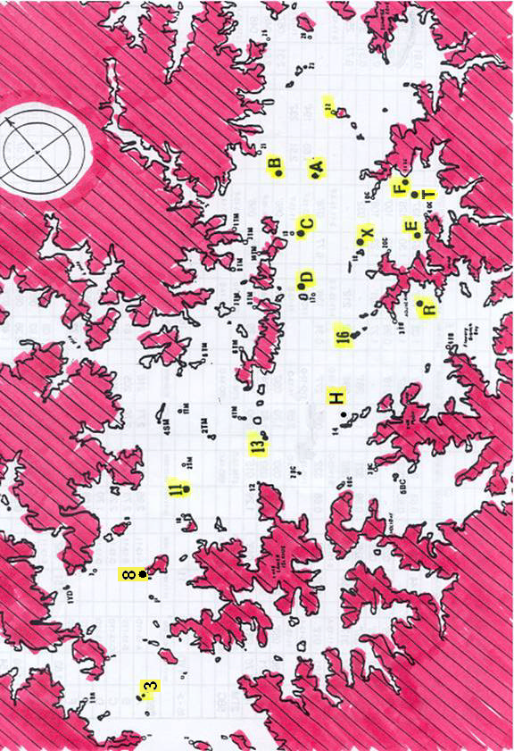Appendix B – Racing Area Map for Keelboat courses